Program Structures and Algorithms

Fall 2024

Group members: Akshit Saxena, Sanskruti Manoria   
Nuids: 002475083, 002643300  
GitHub link: <https://github.com/saxena-akshit/WebKrawler-INFO6205>  
App name : WebKrawler  
Task: Build a web crawler that uses parallel/asynchronous processing to find web pages, given a set of starting pages.

***Contents***  
**1.Abstract**

**2.Web-Crawler Implementation**

**3.Code & Output**

**4.Unit Test Cases**

**5.Benchmarking**

**6.Conclusion**

**7. References**

**4. Test Cases  
  
1. WebCrawlerApplicationTests**

**2. TestControllerTest  
  
3. WebCrwaler Controller Test  
**

**4. WebCrawler Services**

**4.1 Neo4j Tests**

**4.1.2** createNodeExceptionHandling()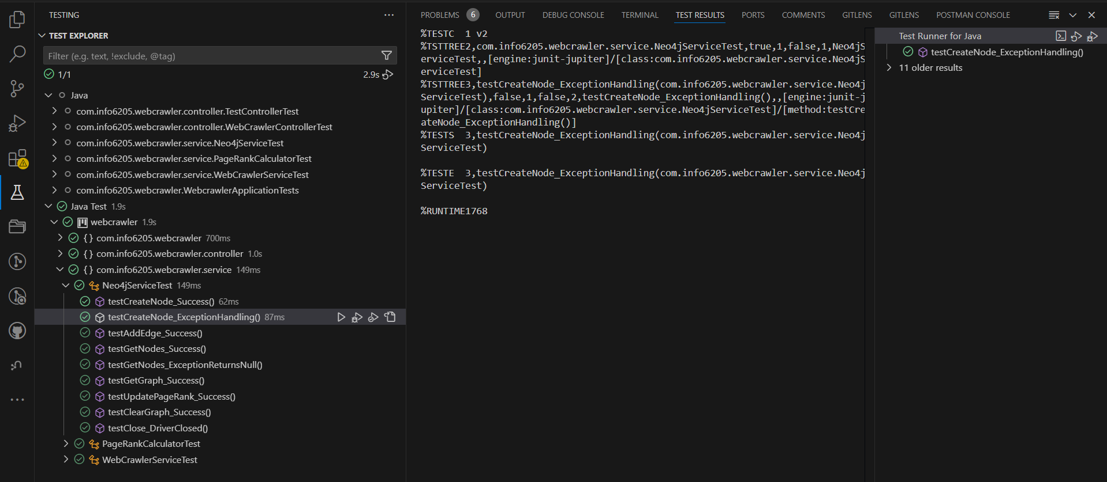

4.1.7 TestUpdatePagerank_Success()

**4.2.PageRankCalculatorTest**

**4.3. WebCrawlerServices**

4.3.11TestNoDuplicateBlackListedEntries()

Overview of Test cases:

